BECOME RED HAT CERTIFIED SYSTEM ADMINISTRATOR
(Lesson 10)

Chapter 10: Containers Management (RHCSA EXAM)

In previous chapter (chapter 09), we described the following major topics:
-Deploy and configure an apache server (RHCSA EXAM)
-Configure NFS server and client
-Configure Autofs and client (RCSA EXAM)
-Configure Samba server and client (cifs)
-Deploy kickstart server and client (advance installation).

This chapter (chapter 10) describes the following major topics:
-Find and retrieve container images from a remote registry
-Perform basic containers management using podman command
-Configure a container to start automatically as a systemd service (RHCSA EXAM)
-Run a service inside a container
-Perform advanced containers management using podman command (RHCSA EXAM)

What are containers?
Containers are virtual boxes that contain your applications and their files dependences that can be isolated. These application can be moved to the productive environment without causing any issues.
The podman and docker commands are used to launch containers.
Note: in these projects, we will use the podman command instead of docker, but they have the same function.
To launch containers, we need to do the followings:
-install the container-tools package.
#yum –y module install container-tools
-install the podman or docker package.
#yum –y install podman
Or
#yum –y install docker
-login to the image registry using the credentials given.
NOTE: you can use your red hat credentials for logging in to the registry.
#podman login registry.rehat.io
-search for the isoimage
#podman search registry.redhat.io
-download the isoimage from the registry.
#podman pull registry.redhat.io<isoimage>
-launch the container.
NOTE: you can use your red hat credentials account to login to the registry and launch containers. Before launching containers, please make sure you have your DNS well configured otherwise you will be unable to login to the registry and launch containers.

- find and retrieve container images from a remote registry
isoimages for containers are located in the registry and need to be found and retrieve for containers launching.
Project:
Find and retrieve the isoimage “/rhel8/rsyslog” located in the registry.
Solution:
-install the container-tools package.
#yum –y module install container-tools
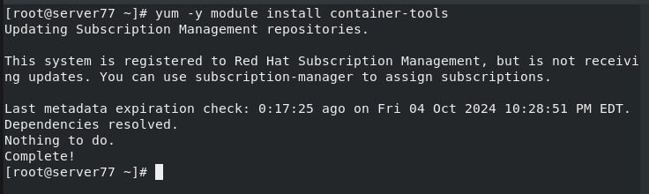
-install podman package.
#yum –y install podman
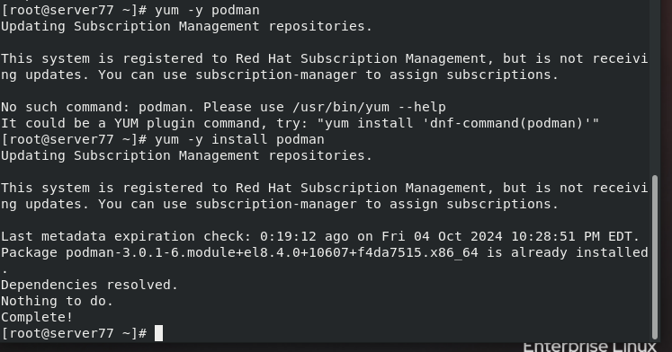
-login to the registry.
#podman login registry.redhat.io
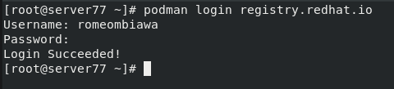
-search for the isoimage /rhel8
#podman search registry.redhat.io/rhel8
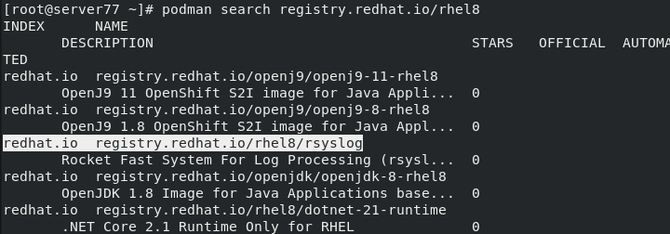
-pull the isoimage /rhel8/rsyslog from the registry.
#podman pull registry.redhat.io/rhel8/rsyslog (to pull the isoimage)
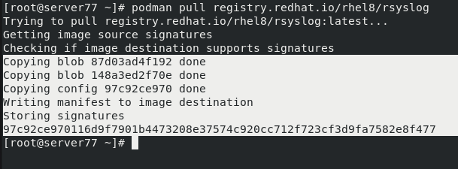
The isoimage /rhel8/rsyslog has been found and retrieve.

2—Perform basic containers using podman command
To launch a basic container, run the commands:
#podman run -dt - -name <container name> <isoimage> and press enter
#podman run -it - -name <container name> <isoimage> and press enter
#podman run –dp - -name <container name> <isoimage> and press enter.
-dt= detach terminal
-it = interact terminal
-dp = detached port
Project 01
Launch a container called “myhomework” using rsyslog as isoimage previously found. The container must be in detach terminal mode. Display myhomework.
Solution:
#podman run –dt - -name myhomework rsyslog and press enter

The container myhomework has been launched in detach terminal mode.
To display a container, user the command:
#podman ps (to display a container)
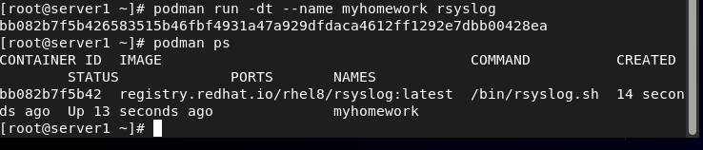
-access a container in detach mode.
To access a container in detach mode, use the command:
#podman attach <container name> and press enter
Or
#podman exec –it <container name> /bin/bash and press enter
Example
Access the container myhomework.
#podman exec –it myhomework /bin/bash
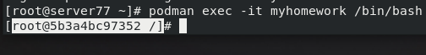
To exit, use the command:
#exit (to exit the container)
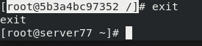

Project 02:
Launch a container called “linux_file using the isoimage /rhel7/ubi7. The container should be in interact terminal (it).
Solution:
-install the container-tools package
#yum –y module install container-tools
-install podman package.
#yum –y install podman
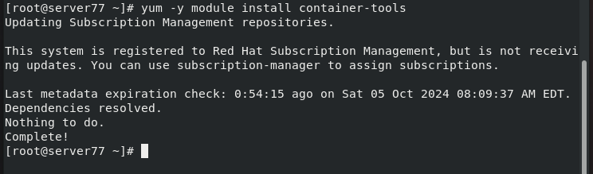
-access the red hat registry.
#podman login registry.redhat.io
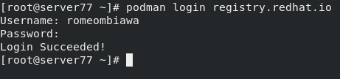
-search for /rhel7/ubi7 isoimage.
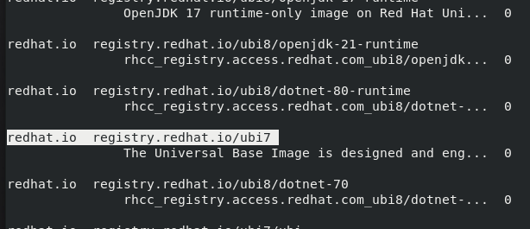
#podman search registry.redhat.io/ubi7
-pull the /rhel7/ubi7 isoimage.
#podman pull registry.redhat.io/ubi7 (to download ubi7 iso)
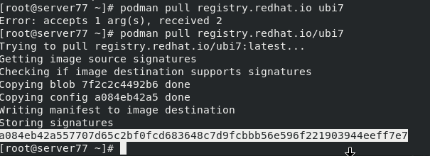
-launch the container linux_file
#podman run –it - -name linux_file ubi7 (to launch the container)
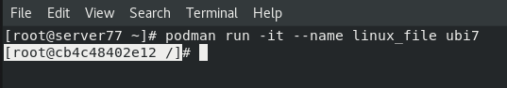
-display the container linux_file.
#podman ps (to display linux_file)
-exit the container linux_file
#exit (to exit the container)
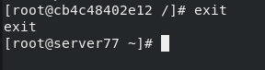

Using port mapping for launching containers
We can use ports (80, 8080, 82) for launching container
Project 03:
Launch a container called “cont_port” in detached mode with host port 10000 mapped to 8000 inside the container using a version of RHEL7 image with apache web server software.
Solution 03:
-access the redhat registry and search /rhel7/httpd isoimage.
#podman search registry.redhat.io/rhel7/httpd
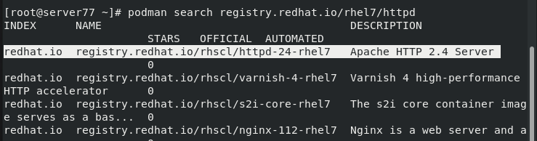
-pull the /rhel7/httpd isoimage.
#podman pull registry.redhat.io/rhscl/httpd-24-rhel7
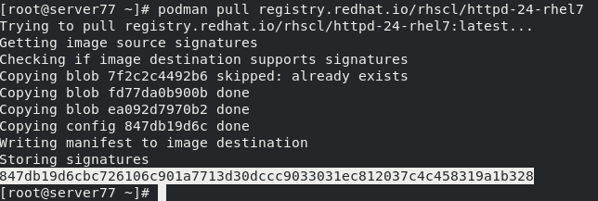
-

launch the container in detached port (-dp).
#podman run –dp 10000:8000 - -name cont_port httpd-24-rhel7
Display the cont_port
#podman ps
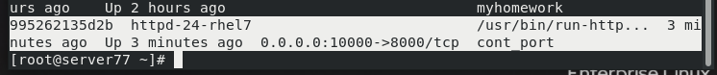

3-configure a container to start automatically at the boot
To configure a container to automatically start at the boot, the unit file has to be generated by the systemd. This file MUST be located in /etc/systemd/system directory. If the file is generated in /root or any directory, just copy it to /etc/systemd/system directory. To avoid doing this, it is preferable to change directory to /etc/systemd/system for any auto start container configuration.
To configure a container to automatically start at the boot, do the followings:
-display the container.
#podman ps
-generate the systemd unit file.
#podman generate systemd - -new - -name <container name> |tee /etc/system/system/<container name>.service (this displays directly the systemd unit file)
Or
#podman generate systemd - -name <container name> -f –n
-enable (- -now) the container service using the systemcl command.
#systemctl enable - -now <container name>
-reload the systemd unit file using the systemctl command
#systemctl daemon-reload
-check the running status of the new service using the systemctl command.
#systemctl status <containe name>

Project 04:
Configure container “myhomework” previously launched to auto start at the boot.
Solution 04
#podman ps (to display)
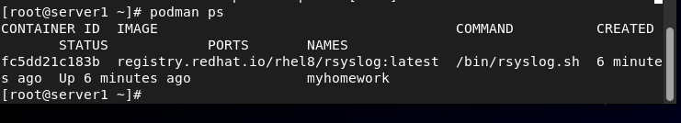
-generate the systemd unit file.
#podman generate systemd - -new - -name myhomework |tee /etc/systemd/system/myhomework.service
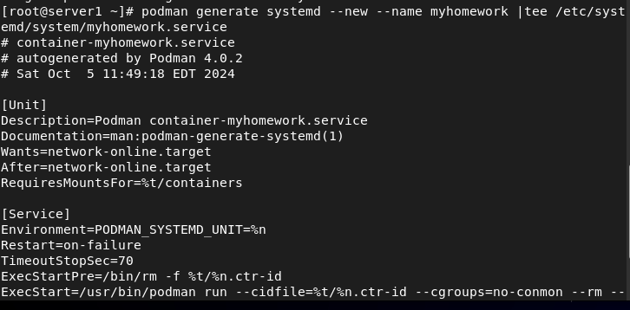
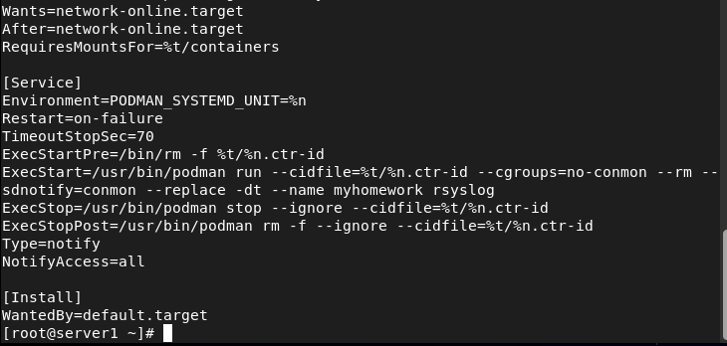
This is the unit file generated by systemd.
Or
#podman generate systemd - -name myhomework –f –n
-enable the container service.
#systemctl enable - -now myhomework
-reload the systemd unit file.
#systemctl daemon-reload
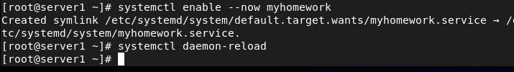
-check the running status of the container myhomework
#systemctl status myhomework
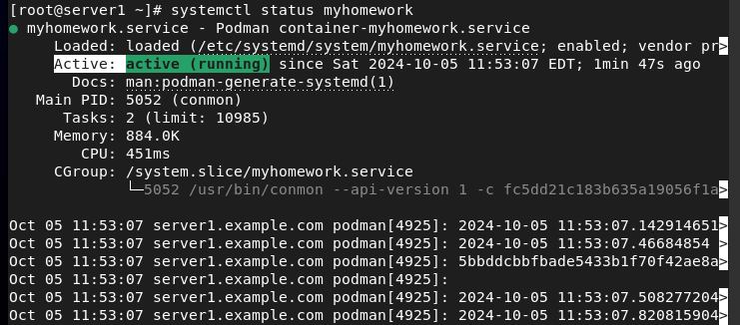
The container “myhomework” will now automatically start at any boot or reboot.

Project 05:
Configure the container “cont_port” launched previously to automatically start at the reboot.
Solution 05:
-display the container cont_port.
#podman ps
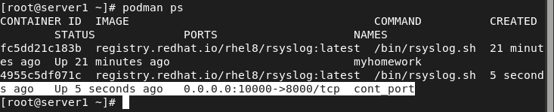
-generate the systemd unit file.
#podman generate system - -name cont_port –f –n
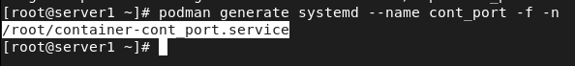
-copy the /root/container-cont_port.service to /etc/systemd/system directory.
#cp /root/container-cont_port.service /etc/systemd/system
-enable the container service (container-cont_port.service)
#systemctl enable - -now container-cont_port.service
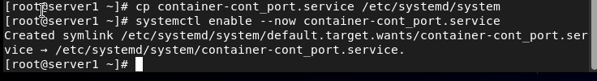
-reload the systemd unit file.
#systemctl daemon-reload
-check the new running
status of the container cont_port
#systemctl status container-cont_port.service
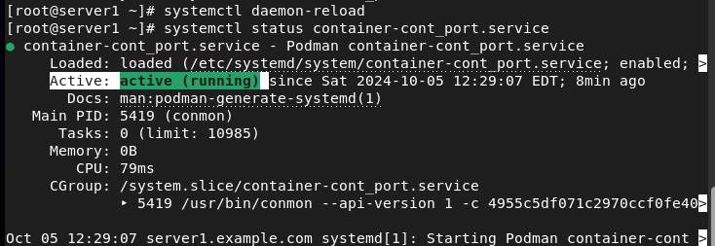
The container cont_port will now automatically start at any reboot.

4-run a service inside a container
We can run multiple services inside a container. For example, list a component of files and directories, create files and directories, copy files and directories and so on.
Project 06:
-access the container “myhomework” previously created and list the component under /root directory. Under /root directory, create a folder called “”container33”. Under container33, create a file called “exam.conf” with the following content “I will pass my RHCSA EXAM. Copy the folder “container33” to /tmp directory.
Solution 06:
-access the container myhomework.
#podman exec –it myhomework /bin/bash (to access myhomework container)
#ls /root
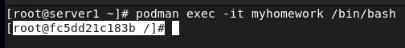
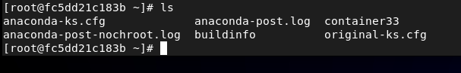
#cd /root (to change directory to /root)
#mkdir container33 (to create the directory container33)
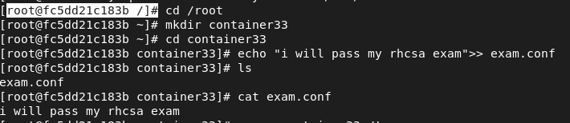
#cd container33 (to change directory to container33)
#echo “I will pass my RHCSA EXAM”>> exam.conf

-copy the directory container33 to /tmp directory.
# cp –r /root/container33 /tmp
-verify
#ls /tmp (to verify)
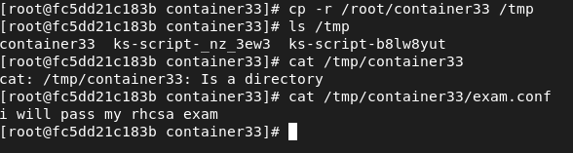

Project 07:
Create user bob with uid 345 and user sophie with uid 555. Give the rwx permission of container33 to bob and the rw permission to user sophie. Modify the attribute of user bob to 333 and the attribute of user sophie to 666.
Solution 07:
Inside the container, do the followings:
#useradd –u 345 bob (to create user bob)
#useradd –u 555 sophie (to create user sophie)
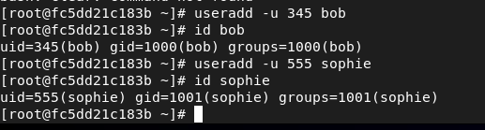
#setfacl –m u:bob:rwx /root/container33 (to give rwx permission to user bob)
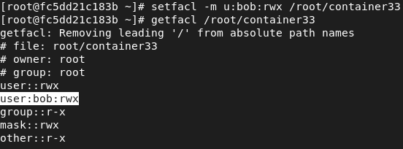
#setfacl –m u:sophie:rw /root/container33
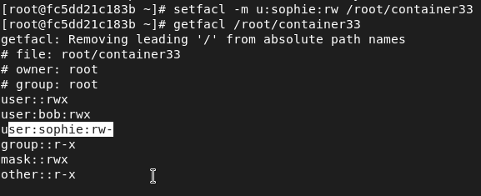
#usermod –u 333 bob
#usermod –u 666 sophie
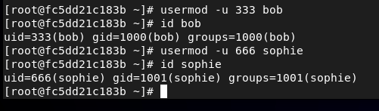
Exit the container myhomework
#exit
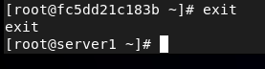

5-perform advanced containers using podman command
In this section, we will perform few advanced containers.
- Containers and Environment Variables.
Project 08:
Launch a container called “mycontainer” using ubi8 as image. You will inject the HISTSIZE environment variable and a variable called “SECRETE” with the value “secret123”. You will launch this container in (-it) mode and you will configure it to auto start at the boot.

Solution 08;
We use the –e option when we want to insect an environment variable and a variable in a container. So the command line will look like this:
#podman run –it –e <environment variable> -e <variable>=”<value>” - -name <container name> <image>
#podman run –it –e HISTSIZE –e SECRET=”secret123” - -name mycontainer ubi8
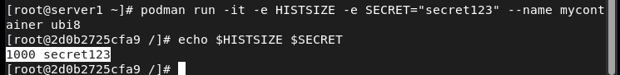
-verify both variable using echo command.
/] #echo $HISTSIZE $SECRET

-exit the container.
#exit
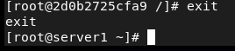
-generate the systemd unit file.
#podman generate systemd - -new - -name mycontainer |tee /etc/systemd/system/mycontainer.service
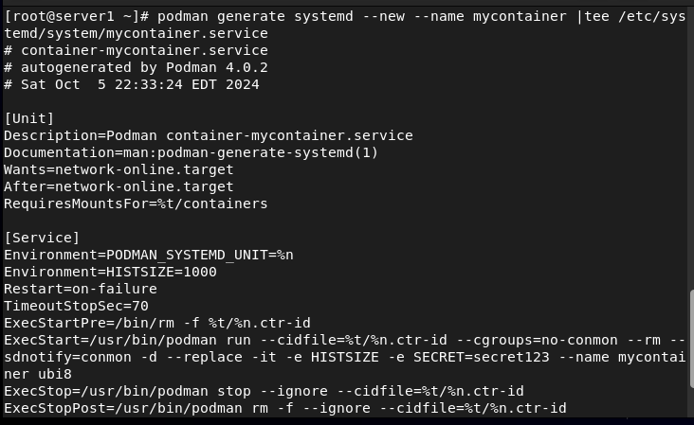
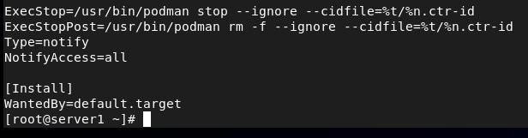
-enable the container mycontainer.
#systemctl enable - -now mycontainer
-reload the unit file.
#systecmtl daemon-reload
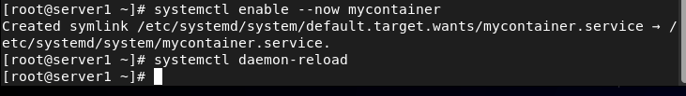
-check the status of mycontainer
#systemctl status mycontainer
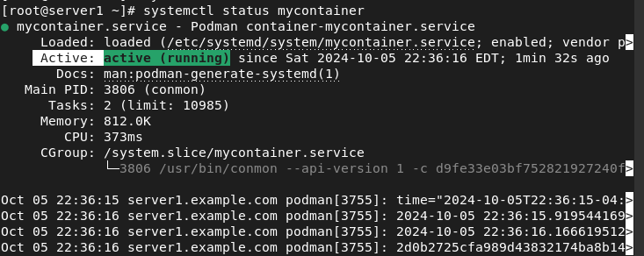

- Launching a container with an existing user

Project 09:
As user root, you will launch a container called “container_data” using ubi8 as image. You will generate the systemd unit file and you will configure it to auto start at the boot. You will access the linger and display user root.
Solution 09:
#cd /root
-create the directory ~/.config/systemd/user –p
#mkdir ~/.config/systemd/user –p
-launch the container called container_data.
#podman run –dt - -name container_data ubi8
#podsman ps (to display)
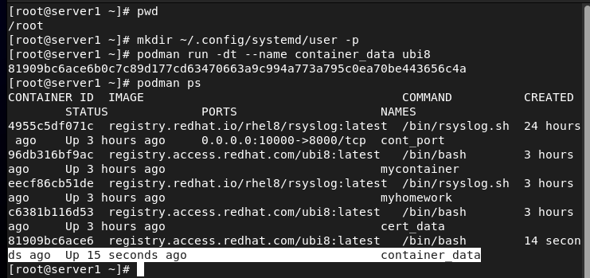
-generate the systemd unit file.
#podman generate system - -new - -name container_data >~/.config/systemd/user/container –data.service
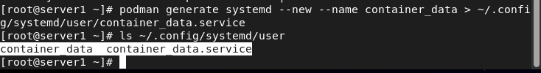
-copy the ~/.config/system/user/container_data to /etc/systemd/system
#cp ~/.config/system/user/container_data /etc/system/system
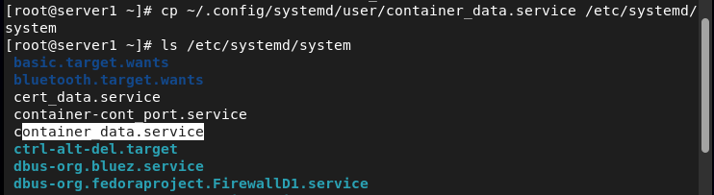
-enable container_data.service
#systemctl enable - -now container_data.service

-reload the systemd unit file.
#systemctl daemon-reload
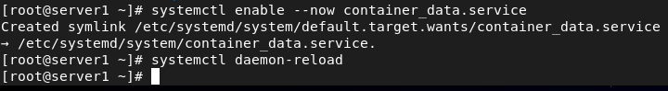
-check the status of container_data.
#systemctl status container_data
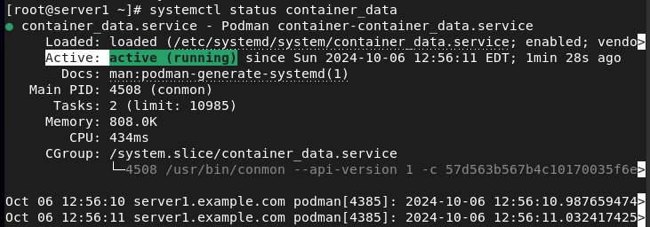
-change directory to ~/.config/system/user.
#cd ~/.config/system/user
-enable the linger using the loginctl command.
#loginctl enable-linger
-display the user root using the loginctl command.
#loginctl show-user root
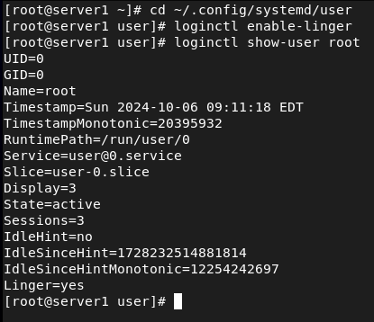

Project 10:
As user sam, you will launch a container called “sam_container” using ubi8 as image. You will generate the systemd unit file and you will configure it to auto start at the boot.
Solution 10:
-create user sam.
#useradd sam ; passwd sam
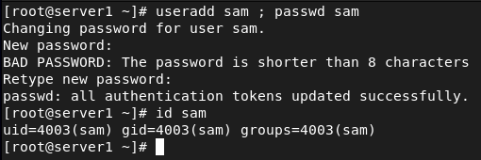
-give the full privilege to user sam.
#vi /etc/sudoers and add:
Sam ALL=(ALL) NOPASSWD: ALL
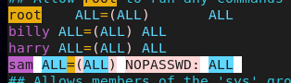
-save and quit (:wq!)
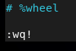
-switch to user sam.
#su sam
-create the directory ~/.config/system/user
-create the directory ~/.config/systemd/user –p
$mkdir ~/.config/systemd/user –p
-launch the container called container_data.
$sudo podman run –dt - -name sam_container ubi8
$sudo podsman ps (to display)
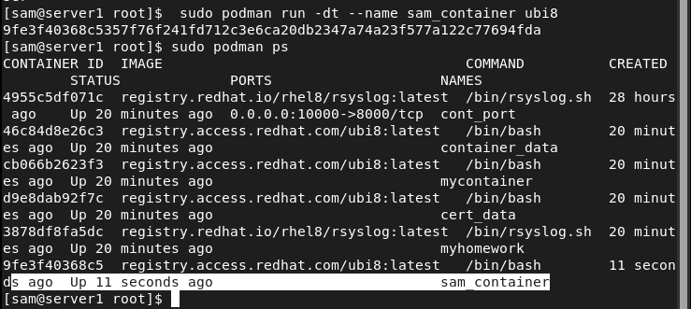
-generate the systemd unit file.
$sudo podman generate systemd - -new - -name sam_container > ~/.config/systemd/user/sam_container.service
-copy the ~/.config/system/user/sam_container to /etc/systemd/system
$sudo cp ~/.config/systemd/user/sam_container /etc/systemd/system
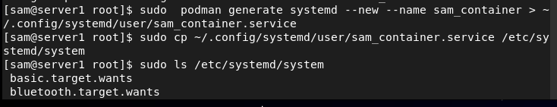
-enable the sam_container.service.
$sudo systemctl enable - -now sam_container.service
-reload systemd unit file.
$sudo systemctl daemon-reload
-check the status of sam_container.
$sudo systemctl status sam_container 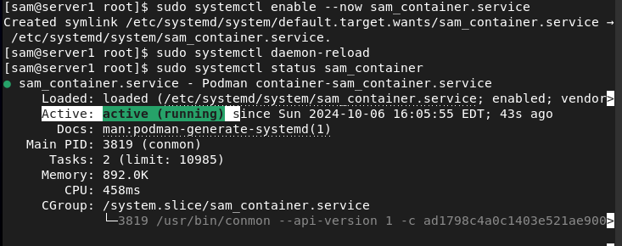

- Launching a container with persistent storage
Project 11:
As root, create a directory called data_container. Under the directory data_container, create a file called “datafile” with the following content “my data are saved in my file”. Launch a container called “cert_data” in -dt mode using ubi8 as image. Attach the directory data_container to the container cert_data using the mount point /cont_file and configure it to auto start at the boot. Access the container cert_data and verify that the file datafile is present. Please check their selinux context and their attributes.

Solution 11:
#cd /root
#mkdir /data_container
#cd /data_container
#echo “my data are saved in my file”>> datafile
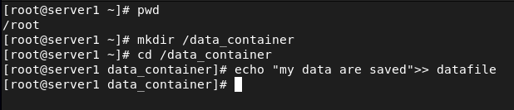
-give the rwx permissions to ugo
#chmod ugo+rwx /data_container
#ls –ld /data_container
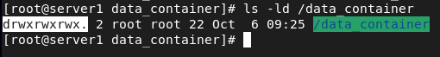
-display the context of the directory /data_container.
#ls –dz /data_container
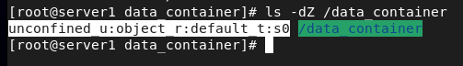
-display the context of the file datafile
#ls –lz datafile
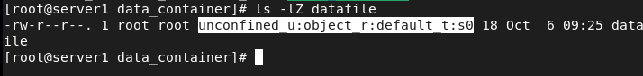
-launch the container cert_data
#podman run –dt - -name cert_data –v /data_container:/cont_file:Z ubi8
-display the container cert_data
#podman ps
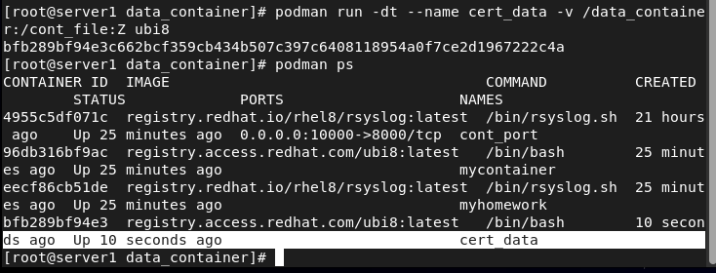
-generate the systemd unit file.
#podman generate systemd - -new - -name cert_data |tee /etc/systemd/system/cert_data.service
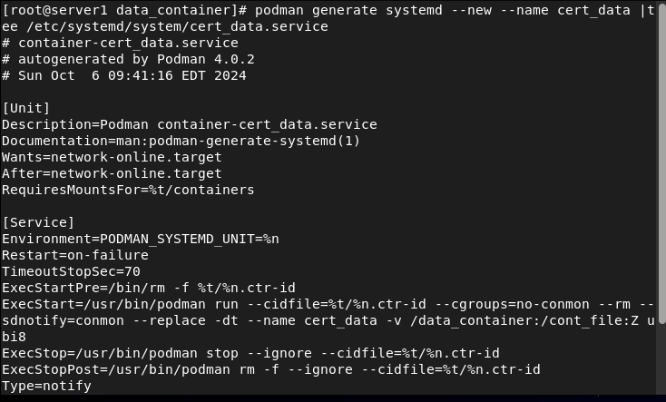
-enable the cert_data.service
#systemctl enable - -now cert_data
-reload the systemd unit fie.
#systemctl daemon-reload
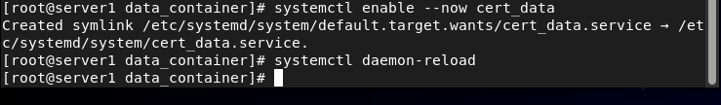
-check the cert_data status.
#systemctl status cert_data
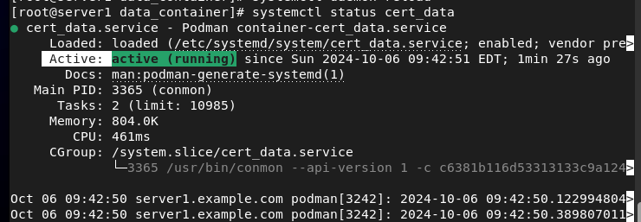
-access the container cert_data
#podman exec –it cert_data /bin/bash
-change the directory to /cont_file.
#cd /cont_file
#ls
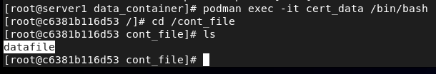
-display the content of datafile
#cat datafile
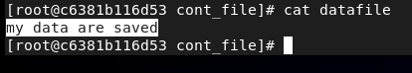
-display the attribute of /cont_file
#ls –ld /cont_file
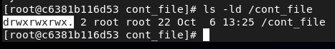
-display the context of the directory /cont_file
#ls –dz /cont_file
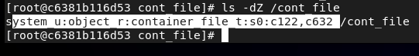
-display the context of the file datafile
#ls –lz datafile
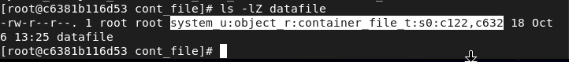
-exit cert_data
#exit
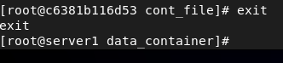
-display the context of the directory /data_container.
#ls –dz /data_container
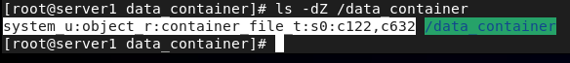
-display the context of file datafile.
#ls –lz datafile
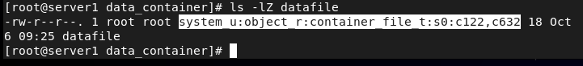
Conclusion:
The content (datafile) of the initial directory (/data_container) is stored in the container (cert_data) under the mount point /cont_data. The initial directory (/data_container) and the mount point (/cert_data) have the same attributes and the same selinux context while the file datafile, the initial directory (/data_container), and the mount point (cont_data) have the same selinux context. This is what they call launching a container with persistent storage.

Starting, stopping, and deleting a container
to start a container, user the command:
#systemctl start - -now <container name>
To stop a running container, use the command:
#podman stop <container name>
To remove a container, use the command:
#podman rm <container name>
Example:
Stop and delete container mycontainer previously launched.
Solution:
#podman stop mycontainer (to stop mycontainer)
#podman rm mycontainer (to delete mycontainer)
#podman ps (to verify)
-start the container mycontainer.
#systemctl start - -now mycontainer (to start mycontainer)
#systemctl status mycontainer (to check its status)
NOTE: a deleted container CANNOT be started or restarted, but a stopped container can be started or restarted.

This is the end of this chapter. Thanks very much for reading and see you for the next chapter (chapter 11).

